**Prevent Blindness Wisconsin**

**Adult Supply Order Form**

Prevent Blindness Wisconsin 🞘 731 N. Jackson Street 🞘 Suite 405 🞘 Milwaukee, WI 🞘 53202

Phone: (414) 765-0505 🞘 Fax: (414) 765-0377 🞘 Email: [Breanna@pbwi.org](mailto:Breanna@pbwi.org)

**Please indicate the QUANTITY on the line on the left:**

______ Adult Vision Care Voucher Application

**PUBLICATIONS:** The price listed is for one pack (100 brochures). *Denotes publications also available in Spanish

|  |  |  |  |
| --- | --- | --- | --- |
| **Title** | **Quantity** | **Title** | **Quantity** |
| Risk Assessment Brochures* |  | Cataract * |  |
| A Checklist for Your Eye Doctor Appointment * |  | Vision Resources & Services for WI Adults |  |
| Age Related Macular Degeneration * |  | Diabetic Retinopathy * |  |
| Growing Older with Good Vision * |  | Open Angle Glaucoma * |  |
| Common Eye Problems* |  | Signs of Possible Eye Trouble in Adults* |  |

**SUPPLIES:**

|  |  |  |  |
| --- | --- | --- | --- |
| **Item** | **Price** | **Quantity** | **Total** |
| **Adult** |  |  |  |
| HOTV / Sloan – 10ft Chart | $17.00 |  |  |
| Lea/Sloan Letter Chart Set (PB23N) | $ 26.00 |  |  |
| Near Acuity Chart (Sloan Letters) | $35.00 |  |  |
| Near Acuity Chart (LEA Symbols and LEA Numbers) | $38.00 |  |  |
| Good-Lite Plastic Occluders (Pack of 6) | $25.00 |  |  |
| Heidi Face Disposable Occluders (50 per package) | $ 25.00 |  |  |
| "Freddy The Fish" Disposable Occluders (500 per package) | $ 50.00 |  |  |
| Amsler Grids (100 pack) | $15.00 |  |  |
| Adult Vision Screening Registration Forms (pack of 100) | $ 22.00 |  |  |
| **Order Total** |  |  |  |

**Date materials are needed:** ________________

Orders will not be placed until payment has been received. Delivery speed is dependent on supplier turnaround time. Orders are placed every two weeks.

**Order Total:** $___________

**\*\*\*Please pay in advance. Purchase orders are not accepted.**

Materials to be sent to:05/18

Name: ___________________________________ Organization: _________________________________________

Mailing Address (DO NOT USE A P.O. BOX): _____________________________________________________________

City: ________________________________________ Zip: ______________ County: ________________________

Phone: ______________________



Email:

**Payment Method:** ❒ **Credit Card** *all major credit cards accepted ❒ **Check** (make checks out to Prevent Blindness Wisconsin)

VISA/MC #: _______________________________________________________ Exp. Date: _____________________

Signature: __________________________________________________________ CSC #: _________________________

**Disposable Occulder Options:**

“Freddy The Fish” Disposable Occluders (500/package)

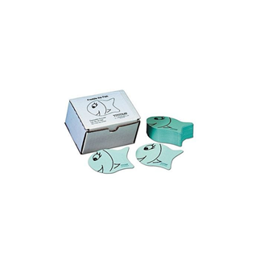

Heidi Face Disposable Occluders (50 per package)

